**Overview**

The Better Building Residential Program Implementation Plan Template will help you develop a strategy for planning, operating, and evaluating a successful residential energy efficiency program. This document identifies the key implementation steps involved with the six program components typically overseen by a program administrator:

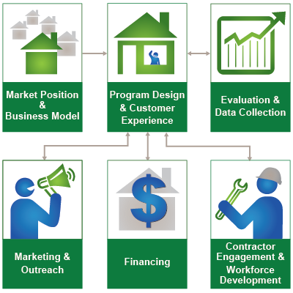

**How to Use this Template**

The 1st column (Step-by-Step) lists implementation steps to consider in each stage of your planning process. The 2nd column (Activities) provides space to brainstorm the activities required for completing each step. The 3rd column (Duration) provides space to define and track internal and external targets. *Note: Launching and improving an energy efficiency program is an iterative process that may not always lend itself to concrete start and end dates for each step provided in the template.*

**Additional Information**

Hyperlinks take you to detailed information about each step, found in the Better Buildings Residential Program Solution Center.

| Financing  Ensure that your program’s customers have access to affordable financing, so they can pay for the products and services you offer. | | |
| --- | --- | --- |
| **Step-by-Step** | **Activities** | **Duration** |
| [Assess the Market](https://bbnp.pnnl.gov/handbooks/financing-%E2%80%93-assess-market)   * Assess the characteristics of target customers and identify gaps * Identify lenders and understand available loan products |  |  |
| [Set Goals & Objectives](https://bbnp.pnnl.gov/handbooks/financing-%E2%80%93-set-goals-objectives)   * Review program goals * Set financing objectives that tie to your program goals * Reach out to stakeholders for insight and refinement |  |  |
| [Identify Partners](https://bbnp.pnnl.gov/handbooks/financing-%E2%80%93-identify-partners)   * Identify lenders * Engage lenders * Determine the process for soliciting proposals from prospective lending partners * Evaluate proposals * Negotiate and execute the lending agreement |  |  |
| [Make Design Decisions](https://bbnp.pnnl.gov/handbooks/financing-%E2%80%93-make-design-decisions)   * Define the financing problem or opportunity that you intend to address * Decide on your program’s financing activities * Determine which functions your program will perform and which functions your partners or subcontractors will perform * Plan for the long-term |  |  |
| [Develop Implementation Plans](https://bbnp.pnnl.gov/handbooks/financing-%E2%80%93-develop-implementation-plans)   * Identify steps relevant to your financing model to implement your financing activities * Document the flow of funds * Establish internal staffing requirements and roles/responsibilities * Develop a timeline for key milestones and a budget for implementing your financing activities * Share your implementation plan with your lending partners |  |  |
| [Develop Evaluation Plans](https://bbnp.pnnl.gov/handbooks/financing-%E2%80%93-develop-evaluation-plans)   * Establish metrics based on your goals and objectives * Design the measurement strategies relevant to your financing model * Establish how data will be transferred, stored, and managed * Design the process and the schedule for data review and assessment |  |  |
| [Develop Resources](https://bbnp.pnnl.gov/handbooks/financing-%E2%80%93-develop-resources)   * Hire and train staff * Identify the resources needed to implement your financing activities * Develop internal and external resources that conform to your program’s brand |  |  |
| [Deliver Program](https://bbnp.pnnl.gov/handbooks/financing-%E2%80%93-deliver-program)   * Prepare to implement your financing activities * Consider a soft launch or pilot to test systems, workflows, and processes * Launch your financing activities and manage them over time, including adjustments to program design based on feedback from stakeholders |  |  |
| [Assess & Improves Processes](https://bbnp.pnnl.gov/handbooks/financing-%E2%80%93-assess-improve-processes)   * Collect and track data * Review and evaluate data * Make decisions to improve your financing activity processes * Communicate process change decisions to your partners |  |  |
| [Communicate Impacts](https://bbnp.pnnl.gov/handbooks/financing-%E2%80%93-communicate-impacts)   * Collect examples, stories, lessons learned, best practices, and data trends that highlight financing successes * Communicate program impacts with your lending partners |  |  |