**Overview**

The Better Building Residential Program Implementation Plan Template will help you develop a strategy for planning, operating, and evaluating a successful residential energy efficiency program. This document identifies the key implementation steps involved with the six program components typically overseen by a program administrator:

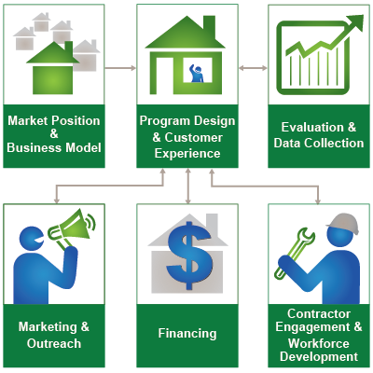

**How to Use this Template**

The 1st column (Step-by-Step) lists implementation steps to consider in each stage of your planning process. The 2nd column (Activities) provides space to brainstorm the activities required for completing each step. The 3rd column (Duration) provides space to define and track internal and external targets. *Note: Launching and improving an energy efficiency program is an iterative process that may not always lend itself to concrete start and end dates for each step provided in the template.*

**Additional Information**

Hyperlinks take you to detailed information about each step, found in the Better Buildings Residential Program Solution Center

| Marketing & outreach  Spur customer demand for your program’s services by understanding your target audience and motivating them to act using effective messaging, marketing and outreach tactics, and attractive program offers. | | |
| --- | --- | --- |
| **Step-by-Step** | **Activities** | **Duration** |
| [Assess the Market](https://bbnp.pnnl.gov/handbooks/marketing-outreach-%E2%80%93-assess-market)   * Develop a market research plan based on available resources and research techniques * Conduct audience research to determine who should be the focus of your marketing and outreach * Categorize your target audiences to narrow the focus of your marketing and outreach efforts |  |  |
| [Set Goals & Objectives](https://bbnp.pnnl.gov/handbooks/marketing-outreach-%E2%80%93-set-goals-objectives)   * Review program goals * Set marketing and outreach objectives that tie to your program goals * Obtain management and stakeholder buy-in and approvals |  |  |
| [Identify Partners](https://bbnp.pnnl.gov/handbooks/marketing-outreach-%E2%80%93-identify-partners)   * Assess gaps that marketing and outreach partners could help fill * Determine and evaluate potential partners * Recruit marketing and outreach partners * Develop a partnership agreement * Engage partners early and often |  |  |
| [Make Design Decisions](https://bbnp.pnnl.gov/handbooks/marketing-outreach-%E2%80%93-make-design-decisions)   * Finalize your priority target audiences * Articulate your value proposition for customers * Develop messages to motivate action * Build a consistent brand platform * Design financial and non-financial incentives * Communicate your decisions to partners |  |  |
| [Develop Implementation Plans](https://bbnp.pnnl.gov/handbooks/marketing-outreach-%E2%80%93-develop-implementation-plans)   * Develop marketing and outreach strategies and tactics * Define marketing and outreach staff needs, roles, and responsibilities * Create a marketing and outreach workplan * Establish a marketing budget * Communicate your plan with stakeholders |  |  |
| [Develop Evaluation Plans](https://bbnp.pnnl.gov/handbooks/marketing-outreach-%E2%80%93-develop-evaluation-plans)   * Identify metrics and evaluation criteria for each marketing and outreach objective * Draft a marketing and outreach evaluation plan * Share your evaluation plan with partners |  |  |
| [Develop Resources](https://bbnp.pnnl.gov/handbooks/marketing-outreach-%E2%80%93-develop-resources)   * Staff and plan to develop marketing and outreach resources * Create a distribution plan * Develop materials that motivate with a call to action * Brand your outreach consistently * Use traditional and modern materials * Share your materials internally and with partners |  |  |
| [Deliver Program](https://bbnp.pnnl.gov/handbooks/marketing-outreach-%E2%80%93-deliver-program)   * Assess your marketing program’s readiness * Consider a pilot or “soft launch” * Launch your marketing efforts * Build on what works and adjust as needed |  |  |
| [Assess & Improves Processes](https://bbnp.pnnl.gov/handbooks/marketing-outreach-%E2%80%93-assess-improve-processes)   * Track progress using key metrics * Collect customer and partner feedback * Review and evaluate data * Decide how to improve marketing efforts mid-stream and reconsider overall marketing strategies if necessary * Communicate decisions to partners |  |  |
| [Communicate Impacts](https://bbnp.pnnl.gov/handbooks/marketing-outreach-%E2%80%93-communicate-impacts)   * Collect marketing and outreach successes and lessons learned as you go * Share marketing and outreach impacts internally and with partners |  |  |