**Overview**

The Better Building Residential Program Implementation Plan Template will help you develop a strategy for planning, operating, and evaluating a successful residential energy efficiency program. This document identifies the key implementation steps involved with the six program components typically overseen by a program administrator:

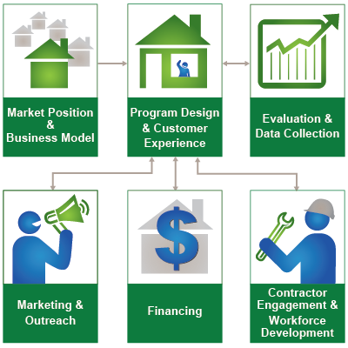

**How to Use this Template**

The 1st column (Step-by-Step) lists implementation steps to consider in each stage of your planning process. The 2nd column (Activities) provides space to brainstorm the activities required for completing each step. The 3rd column (Duration) provides space to define and track internal and external targets. *Note: Launching and improving an energy efficiency program is an iterative process that may not always lend itself to concrete start and end dates for each step provided in the template.*

**Additional Information**

Hyperlinks take you to detailed information about each step, found in the Better Buildings Residential Program Solution Center.

| Evaluation & Data Collection  Develop evidence-based insights into your program’s performance through third-party process and impact evaluations. Craft data collection strategies and timely evaluations to identify important program achievements and opportunities for making improvements. | | |
| --- | --- | --- |
| **Step-by-Step** | **Activities** | **Duration** |
| [Develop Evaluation Plans](https://bbnp.pnnl.gov/handbooks/evaluation-data-collection-%E2%80%93-develop-evaluation-plans#tabs=0)   * Determine the type(s) of evaluation * Determine the scope of the evaluation(s) * Develop a timeline for evaluation activities * Decide how to determine your program’s cost-effectiveness * Solicit proposals for evaluation services * Evaluate proposals * Negotiate and execute the contract |  |  |
| [Develop Resources](https://bbnp.pnnl.gov/handbooks/evaluation-data-collection-%E2%80%93-develop-resources)   * Identify the types of data you need and how you will collect the data * Identify the processes and tools for collecting and assessing program data * Test your tools and processes before program launch |  |  |
| [Conduct Evaluation](https://bbnp.pnnl.gov/handbooks/evaluation-data-collection-%E2%80%93-conduct-evaluation)   * Oversee evaluation activities * Review evaluation deliverables * Identify and mitigate potential risks * Adjust scope and timeline to accommodate evaluation changes * Communicate progress throughout the evaluation process |  |  |
| [Communicate Impacts](https://bbnp.pnnl.gov/handbooks/evaluation-data-collection-%E2%80%93-communicate-impacts)   * Understand and interpret evaluation results * Choose appropriate communications products and channels to reach your stakeholders * Determine how to present pertinent evaluation results in your communications products * Share evaluation results with program managers |  |  |