Overview
The Better Building Residential Program Implementation Plan Template will help you develop a strategy for planning, operating, and evaluating a successful residential energy efficiency program. This document identifies the key implementation steps involved with the six program components typically overseen by a program administrator:

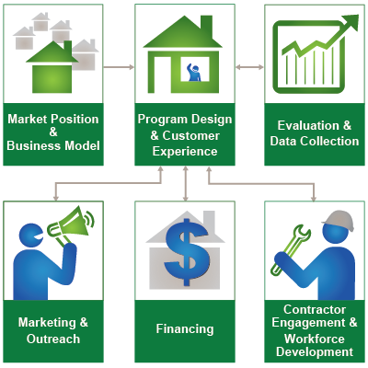

How to Use this Template
The 1st column (Step-by-Step) lists implementation steps to consider in each stage of your planning process. The 2nd column (Activities) provides space to brainstorm the activities required for completing each step. The 3rd column (Duration) provides space to define and track internal and external targets. Note: Launching and improving an energy efficiency program is an iterative process that may not always lend itself to concrete start and end dates for each step provided in the template.

Additional Information
Hyperlinks take you to detailed information about each step, found in the Better Buildings Residential Program Solution Center.
Market Position & Business Model
Identify your organization’s optimal market position by understanding existing market actors, gaps, competitors, and potential partners. Develop a business model that will allow you to sustainably deliver energy efficiency products and services.
Step-by-Step | Activities | Duration
Assess the Market
- Assess potential market demand for energy efficiency products and services
- Assess how the market is served by other organizations and what gaps exist for your organization to fill
- Assess your strengths and capabilities to provide products and services in the market
Set Goals & Objectives
- Examine your organization’s existing vision, mission, and goals
- Define your organization’s vision
- Define the organization’s mission
- Develop S.M.A.R.T. goals
- Get buy-in from your organization’s stakeholders
Identify Partners
- Understand the business models of potential partners
- Approach potential partners and develop a partnership framework
Develop a Business Model
- Determine what services to provide
- Determine how you will deliver program services
- Determine the customers to whom you will provide services
- Determine what assets and infrastructure you will need to implement your program
- Identify sources of funding and operation costs to develop your financial model
- Determine your governance structure
- Outline your business model
- Decide whether to proceed based on the viability of the business model
Create a Business Plan
- Describe your assets and infrastructure
- Describe your products and services
- Describe your market and customers
- Describe your partners and competitors
- Summarize your organization’s governance
- Describe your financial structure
- Write your executive summary
Develop Evaluation Plans
- Reassess your market position
- Reconsider your vision, mission, and goals
- Revisit your business model
- Review key policies
- Identify risks and uncover new opportunities
- Gather sufficient information for decision-making
Develop Resources
- Define resources to help you reach your goals
- Assess current resources and identify gaps
- Take action to fill resource gaps
Assess & Improves Processes
- Track and collect data on your organization’s performance
- Review and assess the data you have collected
- Make decisions and implement solutions based on your data analysis
- Regularly review and re-evaluate your data to ensure continuous improvement
Communicate Impacts
- Link events, milestones, and activities to your communications strategy
- Define the purpose of your communication
- Identify audiences
- Decide on key information and messages
- Choose and develop products
- Choose and use communication channels
- Assess and refine your communication strategy

