**Overview**

The Better Building Residential Program Implementation Plan Template will help you develop a strategy for planning, operating, and evaluating a successful residential energy efficiency program. This document identifies the key implementation steps involved with the six program components typically overseen by a program administrator:

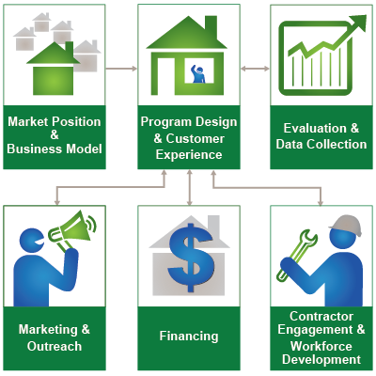

**How to Use this Template**

The 1st column (Step-by-Step) lists implementation steps to consider in each stage of your planning process. The 2nd column (Activities) provides space to brainstorm the activities required for completing each step. The 3rd column (Duration) provides space to define and track internal and external targets. *Note: Launching and improving an energy efficiency program is an iterative process that may not always lend itself to concrete start and end dates for each step provided in the template.*

**Additional Information**

Hyperlinks take you to detailed information about each step, found in the Better Buildings Residential Program Solution Center

| Program Design & Customer Experience  Design a residential energy efficiency program that provides customers with a positive experience by integrating marketing and outreach, contractor coordination, incentives, financing, and program evaluation in a streamlined way. | | |
| --- | --- | --- |
| **Step-by-Step** | **Activities** | **Duration** |
| [Assess the Market](http://bbnp.pnnl.gov/handbooks/program-design-customer-experience-–-assess-market)   * Understand market demand, local policies, and building stock * Assess your potential customers’ motivations for home energy upgrades * Assess your potential customers’ need for loans and other financial products * Assess your local contractor network and workforce development resources * Analyze program strengths, weaknesses, opportunities, and threats (SWOT) to inform design |  |  |
| [Set Goals & Objectives](http://bbnp.pnnl.gov/handbooks/program-design-customer-experience-–-set-goals-objectives)   * Set long-term program goals * Set specific and measurable program objectives * Set objectives for individual program components * Get input from stakeholders |  |  |
| [Identify Partners](http://bbnp.pnnl.gov/handbooks/program-design-customer-experience-–-identify-partners)   * Identify areas where your program would benefit from added strength * Identify potential partners that can strengthen your program * Recruit partners by understanding their goals and motivations * Establish ongoing coordination and communication with partners |  |  |
| [Make Design Decisions](http://bbnp.pnnl.gov/handbooks/program-design-customer-experience-–-make-design-decisions)   * Select your target market sector(s) * Identify barriers to overcome with customers * Select your products and/or services for customers * Determine how you will deliver services * Select and design key program coordination and communication activities * Get feedback on your program design |  |  |
| [Develop Implementation Plans](http://bbnp.pnnl.gov/handbooks/program-design-customer-experience-–-develop-implementation-plans)   * Identify the program components your program will undertake * Use workflow diagrams to illustrate and refine program processes * Establish staffing requirements, roles, and responsibilities for all aspects of program implementation * Develop a program budget * Use a project management approach to integrate and sequence program pre-launch, launch, and operational activities |  |  |
| [Develop Evaluation Plans](http://bbnp.pnnl.gov/handbooks/program-design-customer-experience-–-develop-evaluation-plans)   * Establish program metrics that reflect your goals and objectives * Establish direct and indirect customer experience metrics * Document measurement strategies for collecting data * Establish responsibilities for internal review of evaluation results |  |  |
| [Develop Resources](http://bbnp.pnnl.gov/handbooks/program-design-customer-experience-–-develop-resources)   * Decide who will implement the program * Hire and train a program team * Develop project tracking systems * Develop customer care resources * Develop customer intake process templates and forms * Develop financial processing systems for incentives (as needed) |  |  |
| [Deliver Program](http://bbnp.pnnl.gov/handbooks/program-design-customer-experience-–-deliver-program)   * Before launch, ensure that all resources and processes are in place for delivering the program * Consider a soft launch to test systems, workflows, and processes * Launch the program * Manage the program effectively over time |  |  |
| [Assess & Improves Processes](http://bbnp.pnnl.gov/handbooks/program-design-customer-experience-–-assess-improve-processes)   * Track quantitative and qualitative information for assessing program process and impacts * Establish internal and external processes for reviewing and communicating program performance * Regularly review and assess program metrics and feedback to determine what is working well and what is not * Make decisions about program design changes and communicate them |  |  |
| [Communicate Impacts](http://bbnp.pnnl.gov/handbooks/program-design-customer-experience-–-communicate-impacts)   * Determine communications requirements and purpose * Develop a communications strategy * Gather quantitative and qualitative information, including customer feedback * Evaluate communications channels * Develop communications products * Evaluate and refine your communications strategy |  |  |